DBS211 – Final Project

**Milestone 3 – Database Scripting and Creation**

Seneca College

Course Code: DBS211

Professor’s Name: Clint MacDonald

Group No.: **Group 6**

Group Members: Chaeyoung Park, Saetbyeol Lim, Essie Lee

Student No.: 011784154, 149814212, 185267218

Date of Submission: Aug 13, 2022

Zoo Animal Inventory System

Table of Contents

-ERD

-Data Dictionary

**-ERD**

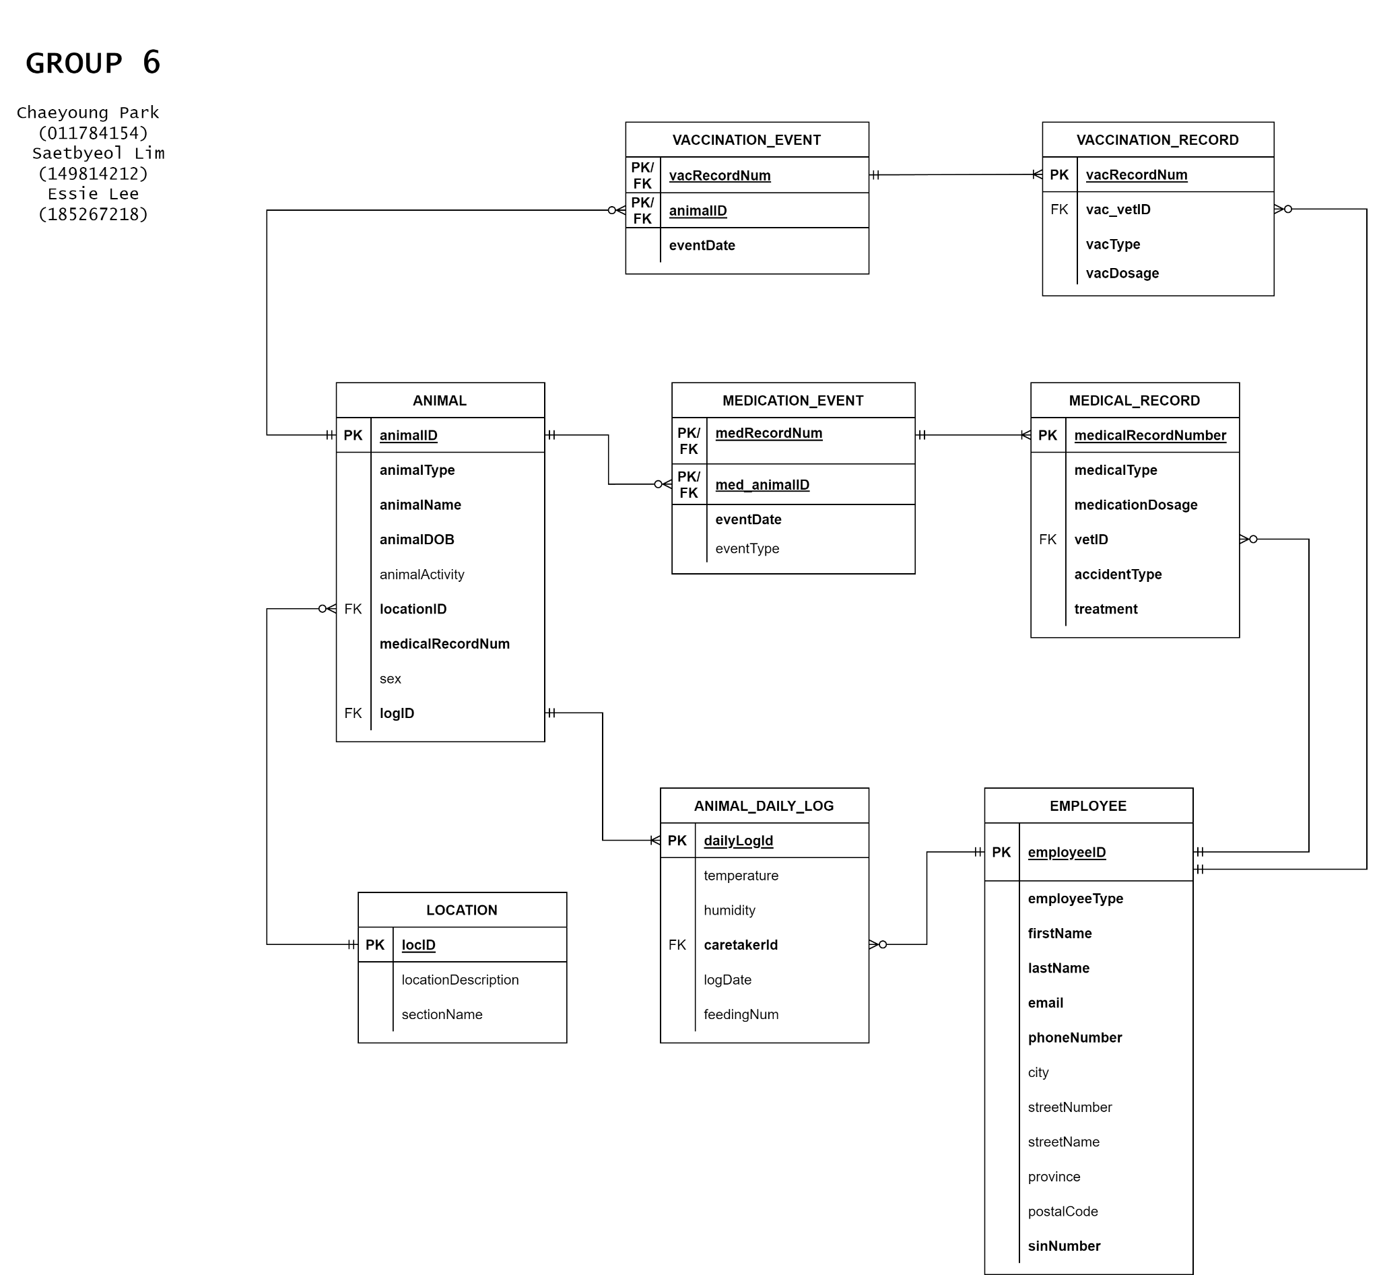

**-Data Dictionary**

TABLE: **ANIMAL**

|  |  |  |  |  |  |  |  |  |
| --- | --- | --- | --- | --- | --- | --- | --- | --- |
| **Column** | **Data Type** | **Size, Precision** | **Default** | **PK/FK** | **Required** | **Range** | **Sample Data** | **Notes** |
| animalID | NUMBER | (9,0) |  | PK | Y | 1-99999999 | 12345678 | Autonumbered identity |
| animalType | VARCHAR2 | 255 |  |  | Y |  | Reptile |  |
| animalName | VARCHAR2 | 255 |  |  | Y |  | Chameleon |  |
| animalDOB | DATE |  |  |  | Y |  | 1972/05/16 | Date of Birth (YYYY/MM/DD) |
| animalActivity | CHAR | 1 |  |  |  | N or D | D | N for nocturnal, D for diurnal |
| locationID | NUMBER | (5,0) |  | FK | Y | 1-9999 | 1234 |  |
| medicalRecordNum | NUMBER | (9,0) |  | FK | Y | 1-99999999 | 12345678 |  |
| sex | CHAR | 1 |  |  |  | M, F or H | F | M for Male, F for Female or H for Hermaphrodites |
| logID | NUMBER | (9,0) |  | FK | Y | 1-99999999 | 12345678 |  |

TABLE: **LOCATION**

|  |  |  |  |  |  |  |  |  |
| --- | --- | --- | --- | --- | --- | --- | --- | --- |
| **Column** | **Data Type** | **Size, Precision** | **Default** | **PK/FK** | **Required** | **Range** | **Sample Data** | **Notes** |
| locID | NUMBER | 5 |  | PK | Y | 1-9999 | 1234 | Autonumbered identity |
| locationDescription | VARCHAR2 | 255 |  |  |  |  | indoor | Indoor/Outdoor |
| sectionName | VARCHAR2 | 50 |  |  |  |  | Asia |  |

TABLE: **ANIMAL_DAILY_LOG**

|  |  |  |  |  |  |  |  |  |
| --- | --- | --- | --- | --- | --- | --- | --- | --- |
| **Column** | **Data Type** | **Size, Precision** | **Default** | **PK/FK** | **Required** | **Range** | **Sample Data** | **Notes** |
| dailyLogId | NUMBER | (9,0) |  | PK | Y | 1-99999999 | 20220802 | Autonumbered identity |
| temperature | NUMBER | (9,1) |  |  |  | -50 to 50 | 30 C | Celsius |
| humidity | NUMBER | (9,1) |  |  |  | 0 to 100 | 50% |  |
| caretakerId | NUMBER | (9,0) |  | FK | Y | 1-99999999 | 20220805 |  |
| date | DATE |  |  |  | Y |  | 2022/08/02 | (YYYY/MM/DD) |
| feedingNum | NUMBER | (9,0) |  |  |  |  |  |  |

TABLE: **EMPLOYEE**

|  |  |  |  |  |  |  |  |  |
| --- | --- | --- | --- | --- | --- | --- | --- | --- |
| **Column** | **Data Type** | **Size, Precision** | **Default** | **PK/FK** | **Required** | **Range** | **Sample Data** | **Notes** |
| employeeID | NUMBER | (38,0) |  | PK | Y | 1-99999999 | 20220810 | Autonumbered identity |
| employeeType | VARCHAR2 | 50 |  |  | Y |  | caretaker |  |
| firstName | VARCHAR2 | 50 |  |  | Y |  | Saetbyeol |  |
| lastName | VARCHAR2 | 50 |  |  | Y |  | Lim |  |
| email | VARCHAR2 | 100 |  |  | Y |  | zoo@gmail.com |  |
| phoneNumber | VARCHAR2 | 50 |  |  | Y |  | 16471112222 | Canada phone number |
| city | VARCHAR2 | 50 |  |  |  |  | Toronto |  |
| streetNumber | NUMBER | (38,0) |  |  |  |  | 50 |  |
| streetName | VARCHAR2 | 50 |  |  |  |  | Charles st east |  |
| province | VARCHAR2 | 50 |  |  |  |  | Ontario |  |
| postalCode | CHAR | 6 |  |  |  |  | M4Y0C3 |  |
| sinNumber | NUMBER | (9,0) |  |  | Y |  | 123456789 |  |

TABLE: **MEDICAL_EVENT**

|  |  |  |  |  |  |  |  |  |
| --- | --- | --- | --- | --- | --- | --- | --- | --- |
| **Column** | **Data Type** | **Size, Precision** | **Default** | **PK/**  **FK** | **Required** | **Range** | **Sample Data** | **Notes** |
| medRecordNum | NUMBER | (9,0) |  | PK/FK | Y | 1-99999999 | 70050123 |  |
| med_animalID | NUMBER | (9,0) |  | PK/FK | Y | 1-99999999 | 12345678 |  |
| eventDate | DATE |  |  |  | Y |  | 2022/08/05 | (YYYY/MM/DD) |
| eventType | VARCHAR2 | 50 |  |  |  |  | Injury |  |

TABLE: **MEDICAL_RECORD**

|  |  |  |  |  |  |  |  |  |
| --- | --- | --- | --- | --- | --- | --- | --- | --- |
| **Column** | **Data Type** | **Size, Precision** | **Default** | **PK/FK** | **Required** | **Range** | **Sample Data** | **Notes** |
| medicalRecordNumber | NUMBER | (9,0) |  | PK | Y | 1-99999999 | 70050123 | Autonumbered identity |
| medicalType | VARCHAR2 | 40 |  |  | Y |  | haloperidol | Name of medication |
| medicationDosage | NUMBER | (3,2) |  |  | Y | 1-500 | 2.25ml | “ml” |
| vetID | NUMBER | (9,0) |  | FK | Y | 1-99999999 | 56478123 |  |
| accidentType | VARCHAR2 | 50 |  |  | Y |  | Fracture in his left leg |  |
| treatment | VARCHAR2 | 50 |  |  | Y |  | Splint the broken leg |  |

TABLE: **VACCINATION_EVENT**

|  |  |  |  |  |  |  |  |  |
| --- | --- | --- | --- | --- | --- | --- | --- | --- |
| **Column** | **Data Type** | **Size, Precision** | **Default** | **PK/FK** | **Required** | **Range** | **Sample Data** | **Notes** |
| vacRecordNum | NUMBER | (9,0) |  | PK/FK | Y | 1-99999999 | 70050123 |  |
| animalID | NUMBER | (9,0) |  | PK/FK | Y | 1-99999999 | 12345678 |  |
| date | DATE |  |  |  | Y |  | 2022/08/05 | (YYYY/MM/DD) |

TABLE: **VACCINATION_RECORD**

|  |  |  |  |  |  |  |  |  |
| --- | --- | --- | --- | --- | --- | --- | --- | --- |
| **Column** | **Data Type** | **Size, Precision** | **Default** | **PK/FK** | **Required** | **Range** | **Sample Data** | **Notes** |
| vacRecordNum | NUMBER | (9,0) |  | PK | Y | 1-99999999 | 70050123 | Autonumbered identity |
| vac_vetID | NUMBER | (9,0) |  | FK | Y | 1-99999999 | 56478123 |  |
| vacType | VARCHAR2 | 40 |  |  | Y |  | rabies | Name of Vaccine |
| vacDosage | NUMBER | (4,0) |  |  | Y | 1-999 | 1 | The first dose |